USER MANUAL

The Scheduler is a system used by undergraduate software engineering students at Concordia University, which generates a class schedule based on the student’s record. It can be accesses from: https://schedule-heroku.herokuapp.com/index.

**Logging In**

Upon entering the website, a username and password will be needed to identify the user and allow access to the Scheduler. Returning users can simply login, while new users will be required to create a new account using the button “Create Account”.

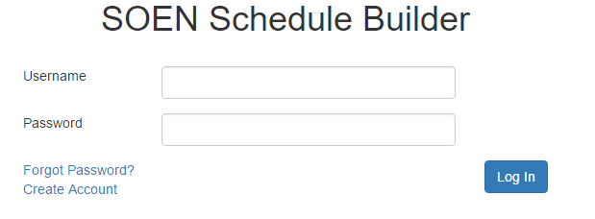

**Figure 1:** *Home Page*

**Resetting the Password**

If one of the returning users forgot their password, they can press the “Forgot Password?” link, which will allow them to reset their password by receiving a temporary one through e-mail. Successfully logging in will grant access to the menu page.

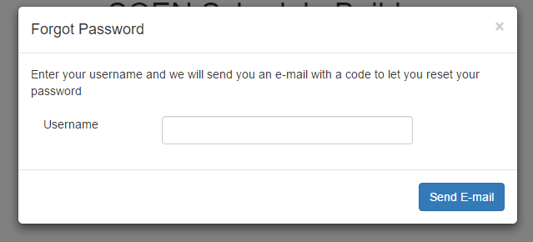

**Figure 2:** *Resetting Password*

**Account Creation**

When first time users click on “register”, the screenshot below will be shown. They will simply have to follow the instruction and fill out each box with the required information. Once this is done, the menu page will open.

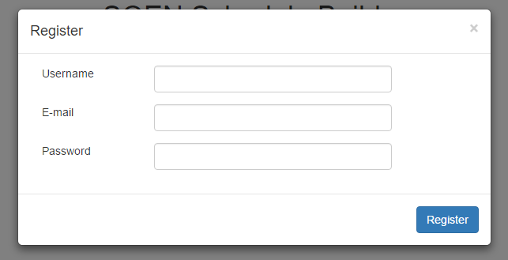

**Figure 3:** *Signing up*

The menu page is accessed after entering a valid username and password or after creating an account. This is where students make all their decisions concerning their schedule.

Here are the different actions users can choose in the menu page:

**Preferences:**

In this page, the users will first see when and where they would like to take courses. As seen in the screenshot below, the choices of having a day of the week off, taking classes in the morning afternoon or at night and the number of classes to take in the semester are all preferences to be set.

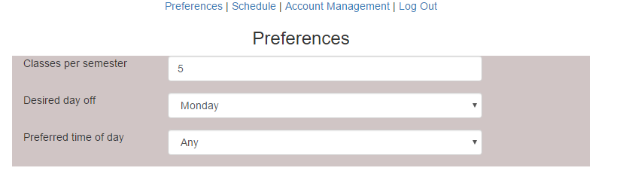

**Figure 4:** *Modifying preferences*

**Adding classes**

The preferences page also allows the students to input their taken courses as well as the needed courses.

One way to add the taken classes by choosing the semester already completed and generating a course list of all the courses that were offered. The user can then simply choose the courses he or she already completed.

The other method is by using the “Add Class” button and manually writing the course name number.

For the needed courses, the same concept is used. Using the “Add Class”, courses can be saved. Each of the saved courses can be edited or removed using the two icons located next to the course numbers.

Using the “build schedule” button seen at the bottom of the page, schedules will be generated and can be accessed in the “Schedule” page.

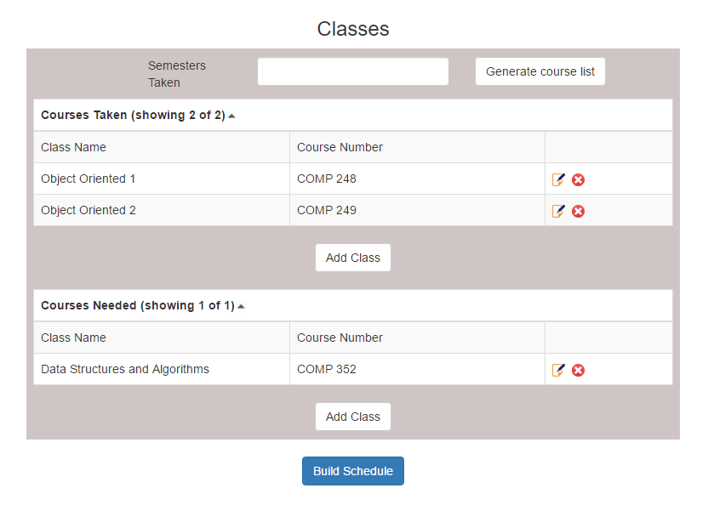**-**

**Figure 5:** *Adding courses*

**Account Management:**

By clicking on the account information link, users can modify their username, email or password (see figure 6).

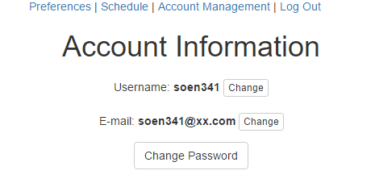

**Figure 6:** Account information

**-Schedule:**

The schedule page is where all the possible schedules corresponding to user’s preferences are going to be generated. It is to be noted that the Scheduler needs the user to input all their taken and needed classes in order to generate a schedule.

The various schedules can be navigated by using the arrows at the top. When a schedule is deemed acceptable, it can be selected using the “Select This Schedule” button. Upon selecting a schedule, the sequence for the rest of the academic years will be created giving a guideline to follow (see figures below).

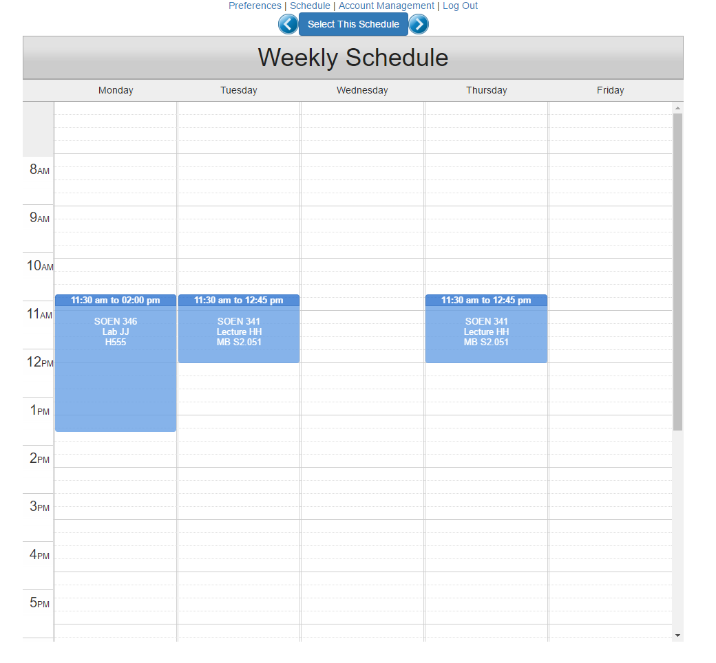

**Figure 7:** *Schedule*

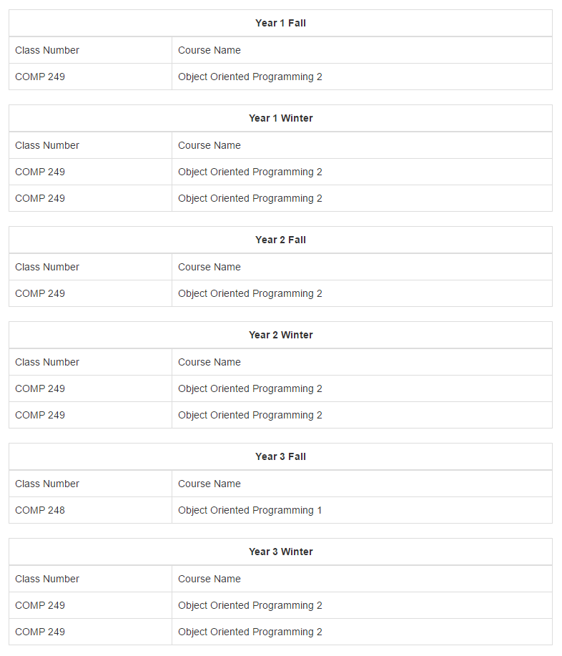

**Figure 8:** *Full sequence*

**\*Disclaimer:** The current state of the system is not completely functional and once all the issues are corrected, a full schedule will be displayed (which will be the case for the last deliverable). The screenshots are also going to be modified once the system is functioning properly.

**Logging out**

To log out, the “log out button” has to be pressed. This will exit the system bring the user back to the home page.

ADMINS MANUAL

The Admins access the website from the same domain name: https://schedule-heroku.herokuapp.com/index.

**Logging Page**

Upon entering the website, a username and password will be demanded. Admins should have a special login username and password to enter the website specifically designed for them.

If the password is forgotten, by clicking on “Forgot Password”, it can easily be recovered.

Successfully logging in brings the Admins to the main page of the website.



Figure 9: Home Page

There are two options in the Admin’s website:

Edit database:

This is where the Admins can add or edit courses present in the database.

Entering this page provides the Admins with a whole list of the courses.

**Adding a Course**

In order to add a course, the button “add class” is to be pressed. This will provide the Admins with a form to fill. More specifically, entering the course number, name and the semester.

**Adding/Modifying Information and Sections**

Next to courses seen on the page, there is a small icon showing a paper and a pencil. By pressing it, it allows the admins to change the descriptions of the course or its number. Also, by clicking on the course name, the different sections of the course are displayed. The same paper and pencil icon can be pressed to modify the time of the sections and the classroom.

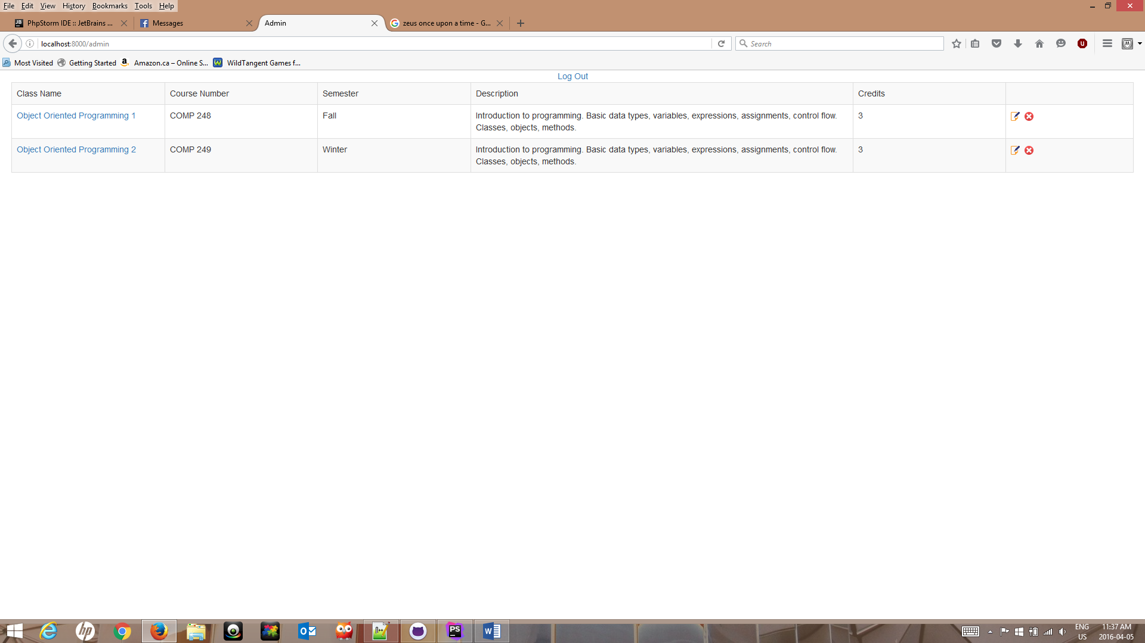

Figure 10: Course list

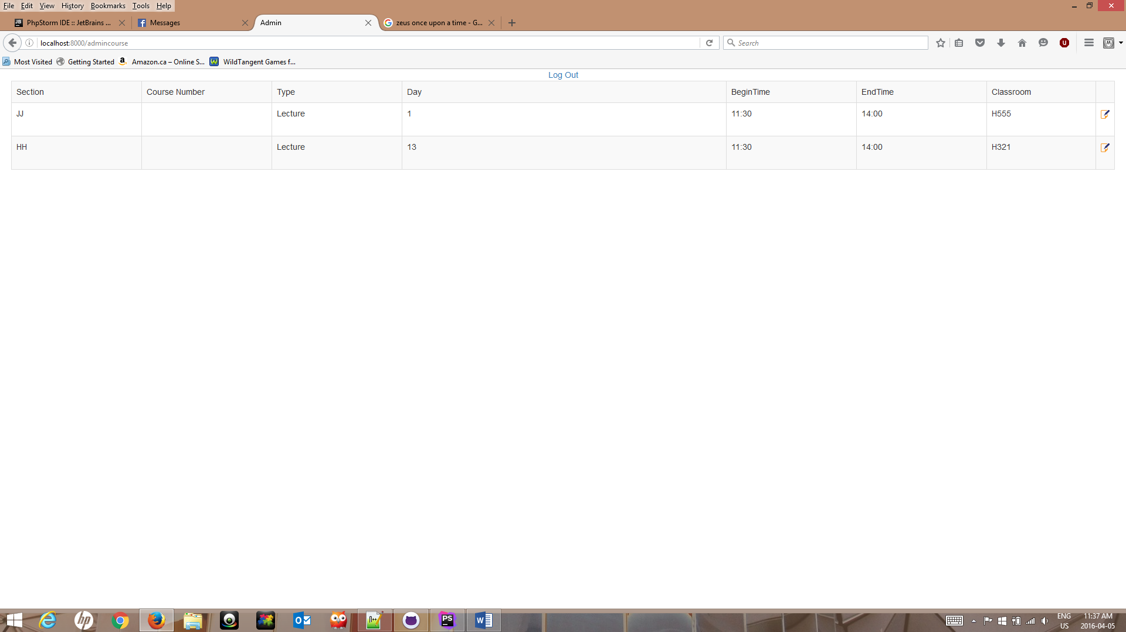

Figure 11: Class Sections

**Log Out**

To log out, Admins can press the “log out” button at the top of the page.